Please refer the steps as below find correct driver for the Wi-Fi card of yours.

Tech-support: [techsupport@lteriver.com](mailto:techsupport@lteriver.com)

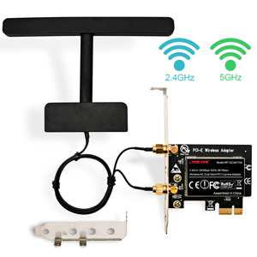

Model: WF-QCA6174A Main Chip: Qualcomm Atheros QCA6174A

Wireless AC PCI Express Network Card 2.4GHz 300Mbps+5GHz 867Mbps

Compatible System: Linux, Windows Server, Windows 10,8.1,8,7 (32/64bits)

Linux Driver Path: PCI Express Serial--- Linux Driver---ATH10K

Windows Driver Path: PCI Express Serial---Qualcomm Networks---Setup.exe

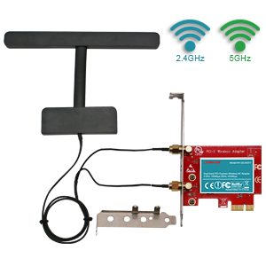

Model: WF-QCA9377 Main Chip: Qualcomm Atheros QCA9377

Wireless AC PCI Express Network Card 2.4GHz 150Mbps+5GHz433Mbps

Compatible System: Linux, Windows 10,8.1,8,7, Windows Server(32/64bits)

Linux Driver Path: PCI Express Serial---Linux Driver---ATH10K

Correct Driver Path: PCI Express Serial---Qualcomm Networks---Setup.exe

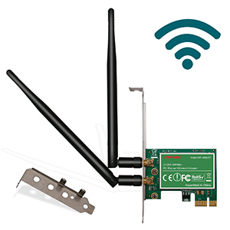

Wireless N PCI Express Wi-Fi Adapter 2.4GHz 300Mbps

Mode: WF-AR9287Main Chip: Qualcomm Atheros AR9287

Linux Driver Path: PCI Express Serial---Linux Driver---ATH9K

Correct Driver Path: PCI Express Serial---Atheros---Setup.exe

Compatible System: Windows 10,8.1,8,7,Windows XP,Windows Server(32/64)